**GitHub Basics**

Under your start menu, start🡪all programs🡪Git there should be 2 options: Git Bash and Git GUI as shown below:

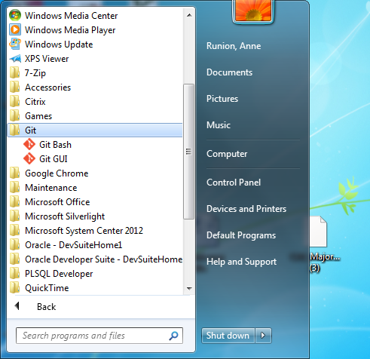

Git Bash is used to check out issues and create issue folders.

Git GUI is used to commit/stage/push the code.

We will be using the Z drive to store documents/scripts.

The full path is: \\nasstor.fastmail.usf.edu\Apps\github\developers

